Class # 1 – Creating Effective Electronic Presentations Using PowerPoint

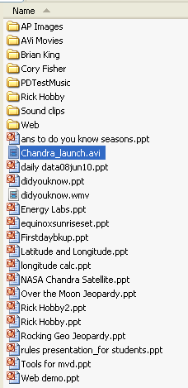
1. Information about Rick, phone number, e-mail. Contents of my CD “Examples”
2. Bathrooms.
3. Break time.
4. Class start and end times.
5. Assignments – Act 48 Credit.
6. Handouts.
7. What is PowerPoint?
8. What is Audacity?
9. Show and Tell examples.
10. Using Windows Explorer.
11. Creating folder(s) for your files Last Name, CD Samples, Web files, My Projects.
12. Copying sample files from your CD.
13. Copying files from my website.
14. What are draw tools and how are they used with PowerPoint?
15. Starting a PowerPoint Presentation
15. From the “Format” Menu, choose “Slide Layout”
17. Type Text into the text boxes provided (Use CTRL M for “More”). Check out the slide layouts
18. From the “Format” Menu, choose “Slide Design” (right click on a slide in the Slide Design Task Bar to change the design of one or all of the slides in your presentation).
19. From the “Slideshow” Menu choose “Slide Transition”.
20. From the “Slideshow Menu” choose “Custom Animation”. This is more powerful than the animation schemes. You control everything.
21. From the “Insert” menu, choose “picture”, then choose “Clipart”.
22. Use the methods you used while reviewing the draw tools to complete your first assignment.

Contents of my CD “PTT Templates”

